EDUCATIONAL ALLIANCE GENERAL EMAIL SIGNATURE

YOUR NAME
Your Position/Title
 | Pronouns (optional)  name@edalliance.org  646-395-1234  917-555-1234  197 East Broadway, New York, NY 10002  edalliance.org

14TH STREET Y EMAIL SIGNATURE

YOUR NAME
Your Position/Title
 | Pronouns (optional)  name@edalliance.org  646-395-1234  344 E 14th Street, New York, NY 10003  14streety.org

CRW EMAIL SIGNATURE

YOUR NAME
Your Position/Title
 | Pronouns (optional)  name@edalliance.org  646-395-1234  917-555-1234  197 East Broadway, New York, NY 10002  edalliance.org
CSYD EMAIL SIGNATURE

YOUR NAME
Your Position/Title
 | Pronouns (optional)  name@edalliance.org  646-395-1234  917-555-1234  197 East Broadway, New York, NY 10002  edalliance.org
MCC EMAIL SIGNATURE

YOUR NAME
Your Position/Title
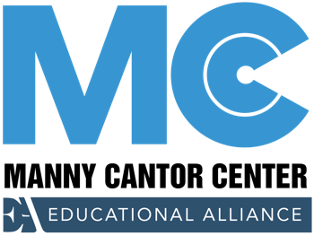 | Pronouns (optional)  name@edalliance.org  646-395-1234  917-555-1234  197 East Broadway, New York, NY 10002  mannycantor.org

NORC EMAIL SIGNATURE

YOUR NAME
Your Position/Title
 | Pronouns (optional)  name@edalliance.org  646-395-1234  917-555-1234  197 East Broadway, New York, NY 10002  edalliance.org

SIROVICH EMAIL SIGNATURE

YOUR NAME
Your Position/Title
 | Pronouns (optional)  name@edalliance.org  646-395-1234  917-555-1234  197 East Broadway, New York, NY 10002  edalliance.org

